Strategy Call & Application — Calendly to Pipedrive Automation

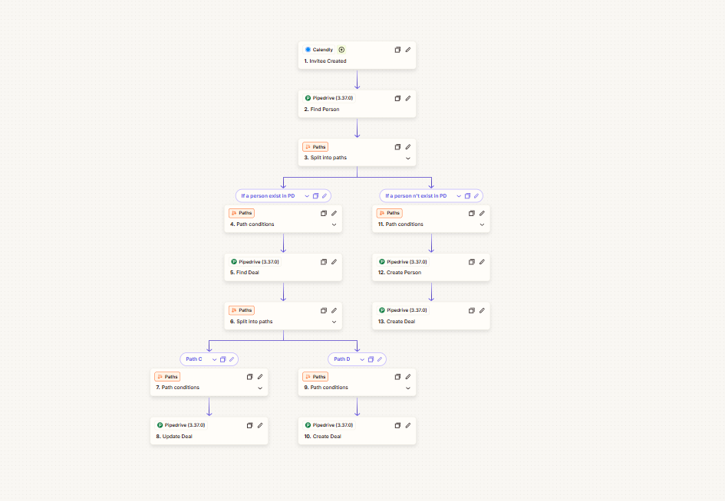

Project Description
An automated lead-to-CRM workflow built to connect Calendly bookings with Pipedrive. When someone schedules a strategy call or submits an application, the workflow checks whether their contact already exists and then determines how the corresponding deal should be handled.
Instead of creating a new record every time, the automation intelligently routes existing and new contacts through different paths, keeping people and deal records organized and reducing unnecessary duplicates.

Automation Scope
- Calendly invitee-created trigger
- Pipedrive contact lookup
- Existing vs. new contact identification
- Conditional workflow routing
- Existing deal lookup
- Deal creation and update logic
- New Pipedrive person creation
- Automated deal creation
- CRM record synchronization
- Duplicate-aware lead processing
- Automated opportunity management

Workflow
Calendly Invitee Created → Pipedrive Find Person → Split Into Paths
Existing Person → Find Deal → Split Into Paths → Update Deal / Create Deal
New Person → Create Person → Create Deal
The workflow first checks whether the person already exists in Pipedrive. Existing contacts are then checked for an associated deal so the automation can either update the current opportunity or create a new one. New contacts are added to Pipedrive along with a corresponding deal.

Key Objective
Automatically turn Calendly strategy-call bookings and applications into properly organized Pipedrive contacts and opportunities, while handling existing records intelligently and keeping the CRM clean and up to date.

